Indigenous Awareness: Tatanka Workshops
Residential School History and Children’s Book Reading
www.tatankaworkshops.com

View: VIDEO TAILER by going to our web site

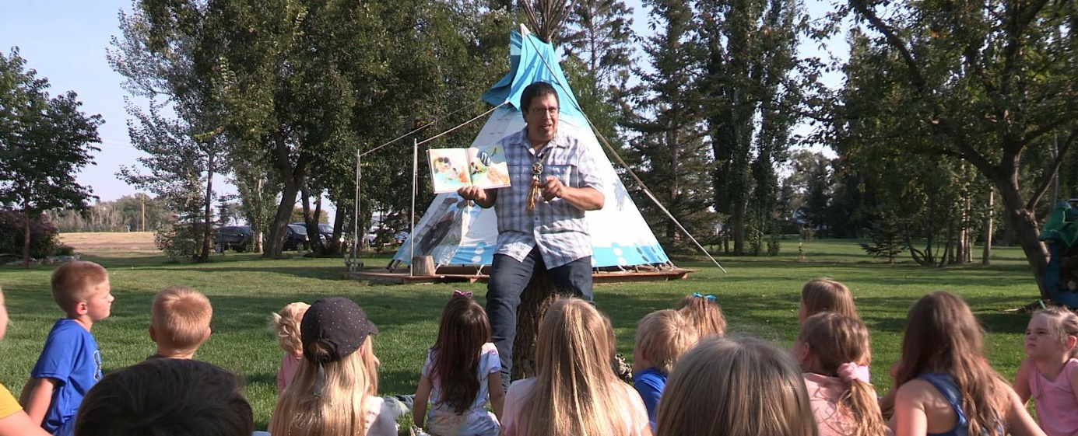
This Indigenous awareness school project includes a history of Canadian Residential Schools presented by author Victor Lethbridge, a member of Wood Mountain Lakota First Nation.
Join thousands of students across our country, for National Day for Truth and Reconciliation, to view this residential school history and book reading. Victor will be presenting personal insights including the intergenerational impact of his Lakota grandfather’s school experience.
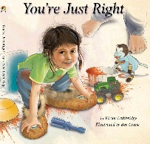
- Video: Available Sept 27, 2021 for schools by ZIP unlock codes.
- Age Focus: Elementary, Jr High and up with age-appropriate activities
- Project Time Frame: Minimum 30-minutes to fit into a classroom period.
- Presenter: Victor Lethbridge - Award winning author/speaker living in Treaty Seven Territory.
- Website Order Form: Order your books and video now. Books will be shipped immediately.

Go to the web site for more information and join us on social media for updates on Victor’s CTV dates and our Call to Action.

- Alberta Teachers: On Sept 27, watch for the registration option for Victor’s teaching session on how to take full use of this video, history, craft, and book reading. Connect with author and motivational speaker Victor Lethbridge as he presents strategies in preserving and restoring Indigenous Culture.

